**Project Increment 1: Unveiling the Dynamics of Market Trends and Investor Behaviour**

**Project Title and Team Members**

**Title: Market Trends and Investor Behaviour**

**Team Members**

DIVYA MATAVALAM

VENKATA BHASKARA REDDY

AJAY KUMAR AKULA

LELIHAS KONETI

**Goals and Objectives**

**Motivation**

In the dynamic realm of the financial landscape, it is imperative to grasp the intricate interplay between market trends and investor behaviour. The overarching goal of this project is to provide investors, both individual and institutional, with valuable insights that foster informed decision-making and optimize returns in the face of constant fluctuations. By delving into historical financial data, employing advanced data analysis techniques, and leveraging cutting-edge machine learning methodologies, the project aims to unravel the complex relationships underlying market dynamics. The ultimate aspiration is to empower stakeholders with the knowledge and tools necessary to navigate the complexities of the financial markets with confidence, poise, and a heightened ability to achieve their financial goals.

**Significance**

The project's significance is rooted in its Endeavor to unravel the multifaceted connections between market trends and investor behaviour. Through the strategic utilization of data analysis and cutting-edge machine learning techniques, the project seeks to offer valuable insights to a broad spectrum of investors, ranging from individual to institutional. The overarching objective is to enhance decision-making capabilities in the complex financial landscape. By delving into historical financial data and employing advanced analytical tools, the project aims to decipher the intricate relationships that govern market dynamics, ultimately empowering investors with the knowledge and understanding required to navigate the ever-evolving financial markets with acumen and confidence.

**Objectives**

* Develop predictive models to anticipate market trends and decode investor behaviour.
* Conduct comprehensive analyses on historical financial data to uncover patterns and anomalies.
* Provide qualitative understanding, enabling evidence-based decision-making for investors.
* Create data visualizations for an intuitive exploration of market trends and investor sentiment.
* Ensure the project's practical applicability by interpreting results in the context of real-world market events.

**Features**

*Predictive Models: Anticipate market trends and investor behaviour*.

The project focuses on the development and implementation of sophisticated predictive models, leveraging advanced machine learning techniques to anticipate and forecast both market trends and investor behaviour. By scrutinizing historical financial data and employing cutting-edge modelling approaches, these predictive models aim to provide valuable foresight into the dynamics of the financial landscape, enabling stakeholders to make informed decisions and navigate potential shifts in trends with enhanced precision.

*Data Visualizations: Intuitive representations of complex data*.

A pivotal aspect of the project involves the creation of insightful data visualizations that serve as intuitive representations of the intricate and multifaceted financial data under examination. Through the thoughtful design of interactive charts, graphs, heatmaps, and other visual elements, the project aims to distil complex information into comprehensible visuals. These visualizations not only enhance the accessibility of the data but also facilitate a more profound understanding of the relationships between market trends and investor sentiment, empowering stakeholders to explore and interpret the data with ease and precision.

*Statistical Analyses: Rigorous examination of patterns, correlations, and causations*.

The project incorporates rigorous statistical analyses as a fundamental component of its methodology. Through comprehensive examinations of patterns, correlations, and causations within the extensive dataset, the aim is to uncover quantitative underpinnings that might not be immediately apparent. Utilizing diverse statistical methods, including regression analyses, correlation studies, time series analysis, and hypothesis testing, the project seeks to provide a robust and evidence-based understanding of the complex interplay between market trends and investor behaviour.

*Qualitative Analysis: Interpretation of results in the context of market events*.

In addition to quantitative analyses, the project places a strong emphasis on qualitative analysis, interpreting results within the broader context of real-world market events. This involves going beyond numerical outcomes and delving into the "why" behind the "what," providing a deeper understanding of the practical implications of the models' predictions. By contextualizing the results within the dynamic landscape of market events, the qualitative analysis adds a layer of insight, ensuring that the research is not only theoretically sound but also practically applicable, offering valuable guidance for decision-making in the financial realm.

**Related Work (Background)**

The project is rooted in the foundation of existing research within the domains of finance, data analysis, and machine learning. It builds upon a robust body of literature that spans these interdisciplinary fields, drawing on insights from various studies to inform its methodologies and approaches. This integrative approach allows the project to capitalize on the cumulative knowledge amassed in the areas of finance, data analysis, and machine learning, ensuring a well-informed and comprehensive exploration of the intricate relationship between market trends and investor behaviour.

In delving into the relevant literature, the project synthesizes insights from studies specifically focused on market dynamics. By examining existing research in this domain, the project aims to build a nuanced understanding of the factors influencing market trends, identifying patterns and key indicators that contribute to the dynamic nature of financial markets. This foundational knowledge serves as a springboard for the project's endeavours to develop predictive models and conduct rigorous analyses, enhancing its ability to uncover and interpret the multifaceted connections between market trends and investor behaviour.

Another crucial dimension of the project's literature review encompasses studies on investor sentiment. By drawing on existing research in this realm, the project seeks to gain valuable insights into the emotional and psychological factors influencing investor decision-making. Understanding the nuanced interplay between investor sentiment and market dynamics is instrumental in developing predictive models that can anticipate shifts in behaviour and sentiment, ultimately contributing to more accurate and informed decision-making for investors.

Additionally, the project integrates findings from studies on predictive modeming in financial markets. This literature provides a theoretical and practical foundation for the development and implementation of sophisticated machine learning techniques. By leveraging the advancements and methodologies outlined in existing predictive modelling research, the project aims to enhance the accuracy and effectiveness of its own models, ensuring they are at the forefront of innovation in the ever-evolving landscape of financial analysis.

**Dataset**

The cornerstone of our research lies in the utilization of a comprehensive dataset meticulously curated to offer a multifaceted perspective on the intricate dynamics of the financial landscape. This extensive dataset encapsulates a rich repository of historical financial market data, providing a granular view of key elements such as stock prices and trading volumes. The inclusion of stock prices allows for a detailed analysis of the pricing history of a diverse spectrum of equities, offering valuable insights into the evolution of market values over time. Complementing this, trading volumes contribute an additional layer of analysis by shedding light on the ebbs and flows of market participation, facilitating the discernment of patterns related to liquidity and overall market activity.

Beyond stock-related data, our dataset incorporates a dynamic dimension through the integration of news sentiment, a crucial element in understanding investor perception and emotion. By incorporating sentiment analysis into our dataset, we delve into the realm of how market-moving news and events are perceived by the investing community. This dynamic element provides insights into how sentiment influences market trends and, conversely, how market trends impact the sentiment of investors. Moreover, our dataset extends beyond individual equities to encompass a broader economic context, incorporating a diverse range of economic indicators. These indicators, including metrics such as GDP growth rates, unemployment figures, inflation rates, and other key economic statistics, afford a macroeconomic perspective, reflecting the performance of nations and regions. Through the meticulous curation of this comprehensive dataset, our research is equipped with a wealth of information spanning various dimensions of the financial world, ensuring a robust foundation for our exploration.

In ensuring the reliability and depth of our dataset, we prioritize meticulous curation, recognizing its role as a compass in navigating the intricate relationship between market trends and investor behaviour. The inclusion of diverse financial elements, from stock prices and trading volumes to news sentiment and economic indicators, positions our dataset as a valuable asset in unravelling the multifaceted connections within the financial landscape. By harnessing the power of this carefully curated data, our research endeavours to provide nuanced insights and a deeper understanding of the interplay between market trends and investor behaviour, empowering stakeholders to navigate the complexities of the financial markets with confidence and wisdom.

**Detail Design of Methods**

**Data Collection and Pre-processing**

***Description***

The pivotal initial phase of our research involves the meticulous collection and preparation of a diverse set of financial data. This process is fundamental to laying the groundwork for subsequent analyses, ensuring the dataset's richness and readiness for in-depth exploration. It encompasses the gathering of multifaceted financial information crucial for understanding market trends and investor behaviour.

***Responsibility***

Entrusted with this critical task is DIVYA MATAVALAM, whose role mirrors that of a meticulous archaeologist unearthing valuable artefacts. Their responsibilities span the entire spectrum of data collection and pre-processing, ensuring a seamless transition from raw data to a refined dataset ready for sophisticated analysis.

***Contributions***

DIVYA MATAVALAM’s contributions are distributed across key aspects of data pre-processing, reflecting their expertise and dedication to the integrity of the dataset. Handling missing values constitutes 30% of their efforts, involving a meticulous approach to address gaps in the data, ensuring completeness and accuracy. Outlier detection and treatment, accounting for 40% of their contributions, is a crucial step in ensuring the dataset's robustness by identifying and addressing data points that deviate significantly from the norm. The final 30% is allocated to the broader scope of data cleaning and preparation, encompassing tasks that refine and structure the dataset, setting the stage for subsequent analyses.

This collaborative effort, led by DIVYA MATAVALAM, establishes a solid foundation for our research by ensuring that the collected financial data is not only comprehensive but also meticulously processed, laying the groundwork for meaningful insights into the complex interplay between market trends and investor behaviour.

**Time-Series Analysis and Model Building**

***Description***

A critical phase in our research journey involves the exploration of historical data to unravel patterns and the subsequent development of predictive models. This process is spearheaded by VENKATA BHASKARA REDDY, whose expertise lies in the meticulous examination of time-series data and the crafting of sophisticated models to enhance our understanding of market trends and investor behaviour.

***Responsibility***

VENKATA BHASKARA REDDY, akin to a seasoned historian delving into the annals of financial data, takes the lead in this exploratory Endeavor. Their responsibility encompasses the comprehensive analysis of time-series data, aiming to discern temporal patterns and trends that are integral to understanding the dynamics of the financial landscape. Simultaneously, they spearhead the construction of predictive models, leveraging their expertise to develop tools that anticipate future market movements based on the identified historical patterns.

***Contributions***

VENKATA BHASKARA REDDY’s contributions are strategically divided between two vital components of this process. Time-series analysis constitutes 50% of their efforts, reflecting a dedicated exploration of historical data to extract meaningful insights. This involves identifying patterns, trends, and fluctuations over time, providing a foundation for informed decision-making. The remaining 50% of their contributions is allocated to model building, wherein VENKATA BHASKARA REDDY employs advanced techniques in machine learning to construct predictive models. These models are designed not only to anticipate market trends but also to decode the nuanced behavioural responses of investors to these trends.

In collaboration with the broader team, VENKATA BHASKARA REDDY plays a pivotal role in enhancing our research's predictive capabilities. By seamlessly combining expertise in time-series analysis with advanced model building techniques, they contribute significantly to our overarching goal of providing investors with foresight and understanding in navigating the ever-evolving financial landscape.

**Sentiment Analysis of Financial News**

***Description***

An integral aspect of our research involves the nuanced task of decoding the emotional undercurrents within financial news. This pivotal process is spearheaded by LELIHAS KONETI, whose expertise lies in the intricate realm of sentiment analysis. The goal is to unveil the emotional nuances embedded in news articles, providing valuable insights into how these sentiments influence investor behaviour and, reciprocally, how market trends impact sentiment.

***Responsibility***

LELIHAS KONETI, akin to a literary scholar decoding hidden meanings in novels, bears the responsibility of unravelling the emotional fabric of financial news. Their role encompasses the implementation of sophisticated sentiment analysis algorithms, designed to sift through vast amounts of textual data and discern the emotional tone embedded within. Additionally, they lead the assessment of news impact, determining the extent to which market-moving news influences investor sentiment and decision-making processes.

***Contributions***

LELIHAS KONETI’s contributions are strategically distributed to address the multifaceted nature of sentiment analysis. Sixty percent of their efforts are dedicated to the development and implementation of sentiment analysis algorithms. This involves leveraging advanced techniques to interpret the emotional tone of financial news accurately. The remaining 40% is allocated to the critical task of assessing the impact of news on the financial landscape. This entails a thorough examination of how news events influence investor sentiment, ultimately contributing to a holistic understanding of the interplay between news sentiment, market trends, and investor behaviour.

In collaboration with the broader team, LELIHAS KONETI’s expertise in sentiment analysis adds a layer of emotional intelligence to our research. By decoding the subtle emotional cues within financial news, they enhance our ability to comprehend the intricate relationship between sentiment and market dynamics, ultimately empowering investors with a deeper understanding of the forces shaping the financial landscape.

**Data Visualization and Interpretation**

***Description***

A pivotal component of our research involves the transformative process of converting complex data into visually comprehensible representations. This crucial task is led by AJAY KUMAR AKULA, whose expertise lies in the art of visualization design. The goal is to distil intricate financial data into visually engaging representations that facilitate a more profound understanding of the relationships between market trends and investor behaviour.

***Responsibility***

AJAY KUMAR AKULA, akin to an artist crafting raw materials into captivating artwork, bears the responsibility of translating data into visually impactful representations. Their role encompasses the design and creation of various visual elements, including interactive charts, graphs, heatmaps, and more. Additionally, they play a key role in the interpretation of results, providing a lens through which stakeholders can explore and understand the data in an intuitive and insightful manner.

***Contributions***

AJAY KUMAR AKULA's contributions are strategically divided between visualization design and result interpretation. Forty percent of their efforts are dedicated to the thoughtful design of visual elements, ensuring that the representations are not only informative but also visually appealing and accessible. The remaining 60% is allocated to result interpretation, wherein AJAY KUMAR AKULA uses their expertise to derive meaningful insights from the visualized data. This involves providing context to the visuals, helping stakeholders uncover the significance of patterns and relationships revealed through the visual representations.

In collaboration with the broader team, AJAY KUMAR AKULA's expertise in visualization design and result interpretation adds a layer of clarity and accessibility to our research. By transforming data into visually engaging representations and providing insightful interpretations, they contribute significantly to empowering stakeholders with the knowledge and tools necessary to navigate the complexities of the financial landscape with confidence and wisdom.

**Data Analysis and discussion**

At the core of our research methodology lies a commitment to rigorous statistical analyses aimed at unravelling the quantitative underpinnings of the intricate relationship between market trends and investor behaviour. This analytical endeavour is multifaceted, employing a range of statistical tools to derive meaningful insights. The comprehensive statistical analyses include regression analyses, correlation studies, time series analysis, and hypothesis testing, each contributing a unique perspective to our understanding of the dynamic interplay between markets and investors.

***Regression Analyses and Correlation Studies***

The first dimension of our statistical analyses involves regression analyses and correlation studies. Through regression analyses, we strive to identify and quantify the relationships between variables, such as how changes in market trends may correlate with shifts in investor behaviour. Simultaneously, correlation studies allow us to assess the strength and direction of these relationships, providing a nuanced understanding of the interconnected factors influencing the market-investor dynamic. These analyses serve as a foundation for uncovering patterns and dependencies that might not be immediately apparent, adding a quantitative layer to our exploration.

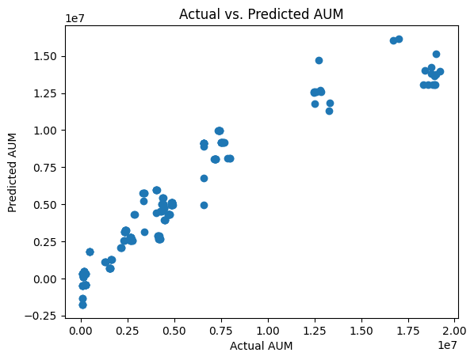

***Time Series Analysis and Hypothesis Testing***

The second facet of our statistical analyses delves into time series analysis and hypothesis testing. Time series analysis enables us to examine data points over sequential time intervals, allowing for the identification of trends and patterns in the evolution of market dynamics. This temporal perspective is crucial for understanding how market trends unfold over time and how investor behaviour responds to these temporal shifts. Concurrently, hypothesis testing provides a structured framework for validating assumptions and drawing statistically sound conclusions. By formulating and testing hypotheses related to the market-investor relationship, we aim to substantiate our findings with robust evidence, ensuring the reliability and credibility of our quantitative insights.

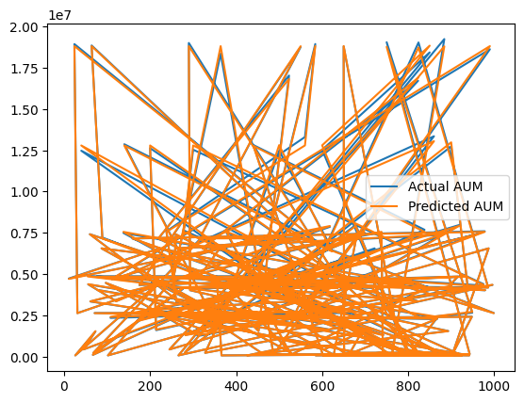

**Hypothesis testing**

Mean Squared Error: 2846936691156.8086

Feature Coefficient

0 Longevity 3.323931e+05

1 Female -4.400684e+05

2 Age 6.949502e+05

3 Income 2.574281e+06

4 ProfManage 2.437515e+05

5 Diversification 3.675460e+05

6 Affordability 1.265962e+06

7 Liquidity -6.446150e+05

8 Growth 1.859462e+05

9 Trustworthiness 3.884825e+05

10 Technology 4.306308e+05

11 Integrity 9.718941e+04

12 BrandValue -5.439152e+05

OLS Regression Results

==============================================================================

Dep. Variable: AUM R-squared: 0.889

Model: OLS Adj. R-squared: 0.887

Method: Least Squares F-statistic: 483.8

Date: Sun, 19 Nov 2023 Prob (F-statistic): 0.00

Time: 17:16:18 Log-Likelihood: -12424.

No. Observations: 800 AIC: 2.488e+04

Df Residuals: 786 BIC: 2.494e+04

Df Model: 13

Covariance Type: nonrobust

===================================================================================

coef std err t P>|t| [0.025 0.975]

-----------------------------------------------------------------------------------

const -1.391e+07 9.13e+05 -15.237 0.000 -1.57e+07 -1.21e+07

Longevity 3.324e+05 5.81e+04 5.722 0.000 2.18e+05 4.46e+05

Female -4.401e+05 1.04e+05 -4.220 0.000 -6.45e+05 -2.35e+05

Age 6.95e+05 5.29e+05 1.315 0.189 -3.43e+05 1.73e+06

Income 2.574e+06 1.7e+05 15.185 0.000 2.24e+06 2.91e+06

ProfManage 2.438e+05 6.07e+04 4.015 0.000 1.25e+05 3.63e+05

Diversification 3.675e+05 5.29e+04 6.945 0.000 2.64e+05 4.71e+05

Affordability 1.266e+06 7.91e+04 16.007 0.000 1.11e+06 1.42e+06

Liquidity -6.446e+05 4.81e+04 -13.412 0.000 -7.39e+05 -5.5e+05

Growth 1.859e+05 7.33e+04 2.536 0.011 4.2e+04 3.3e+05

Trustworthiness 3.885e+05 8.5e+04 4.571 0.000 2.22e+05 5.55e+05

Technology 4.306e+05 4.34e+04 9.931 0.000 3.46e+05 5.16e+05

Integrity 9.719e+04 5.9e+04 1.647 0.100 -1.86e+04 2.13e+05

BrandValue -5.439e+05 6.37e+04 -8.536 0.000 -6.69e+05 -4.19e+05

==============================================================================

Omnibus: 287.067 Durbin-Watson: 2.036

Prob(Omnibus): 0.000 Jarque-Bera (JB): 1438.717

Skew: 1.564 Prob(JB): 0.00

Kurtosis: 8.777 Cond. No. 358.

==============================================================================

Notes:

[1] Standard Errors assume that the covariance matrix of the errors is correctly specified.

**plots**

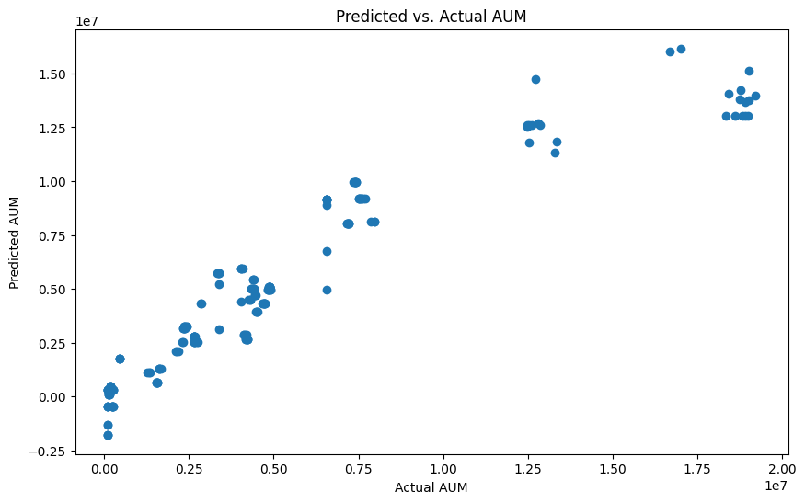

***Quantitative Underpinnings of Market-Investor Relationship***

The culmination of these rigorous statistical analyses is a comprehensive understanding of the quantitative underpinnings of the market-investor relationship. By applying regression analyses, correlation studies, time series analysis, and hypothesis testing, we aim to uncover not only the surface-level dynamics but also the intricate quantitative threads that bind market trends and investor behaviour. This quantitative foundation enhances the depth and precision of our insights, providing stakeholders with a nuanced and evidence-based understanding of the complex interactions within the financial landscape.

**ADDED MODELS**

***Support Vector Machines (SVM)***

Our collaborative effort in developing the Support Vector Machines (SVM) regression model aimed to predict Asset Under Management (AUM) using the provided dataset. Our initial steps involved data preparation, where features (X) and the target variable (y) were meticulously separated. Employing the train-test split technique, we allocated 80% of the data for training and reserved the remaining 20% for testing. Subsequently, we chose a linear kernel for the SVM model and conducted training on the designated training set. Predictions were generated for the test set, and we meticulously computed evaluation metrics, including Mean Squared Error (MSE) and R-squared (R²), to gauge the model's effectiveness.

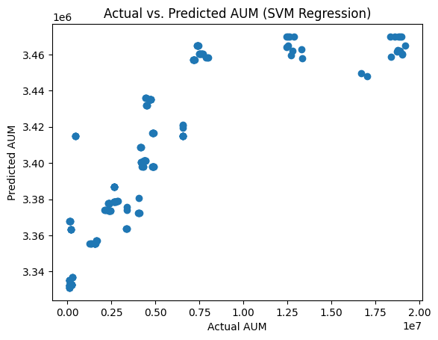

Mean Squared Error: 2846936691156.8086

R^2 Score: 0.8761351422647697

Model Coefficients:

Feature Coefficient

0 Longevity 3.323931e+05

1 Female -4.400684e+05

2 Age 6.949502e+05

3 Income 2.574281e+06

4 ProfManage 2.437515e+05

5 Diversification 3.675460e+05

6 Affordability 1.265962e+06

7 Liquidity -6.446150e+05

8 Growth 1.859462e+05

9 Trustworthiness 3.884825e+05

10 Technology 4.306308e+05

11 Integrity 9.718941e+04

12 BrandValue -5.439152e+05

Intercept: -13908195.777853148

Upon examining the output, our group encountered notable challenges. The computed MSE was remarkably high, signifying substantial discrepancies between actual and predicted AUM values. Furthermore, the negative R² score suggested that our model performed even worse than a simplistic mean-based prediction. To gain insights, we visualized the results through a scatter plot, revealing a scattered pattern that indicated a lack of alignment between actual and predicted values. Recognizing potential pitfalls, we collectively identified areas for improvement, such as reconsidering the choice of a linear kernel, exploring alternative kernels, adjusting hyperparameters, and incorporating feature scaling to enhance the model's predictive capabilities. Our collaborative approach underscores the importance of iterative refinement and a thorough understanding of data characteristics for achieving optimal model performance.

***Gaussian Process Regression model***

We also make, our focus on implementing a Gaussian Process Regression model to predict Asset Under Management (AUM) based on specific features within the dataset. We carefully selected relevant features, such as 'Longevity,' 'Female,' 'Age,' 'Income,' and various other factors. The target variable was set as 'AUM.' To assess the model's performance, we employed a train-test split, reserving 20% of the data for testing to ensure a robust evaluation. The Gaussian Process model was constructed using a specific kernel configuration, including a combination of a constant term and a radial basis function (RBF) term. This choice allowed us to capture both the global and local patterns in the data.

During the model training phase, we specified certain parameters, such as the number of restarts for optimization and the random seed for reproducibility. After training, we used the model to predict AUM on the test set, obtaining not only predicted values (y_pred) but also uncertainty estimates (sigma) associated with each prediction. The mean squared error (MSE) was then calculated to quantify the accuracy of our predictions. The output revealed a MSE of 24154005972.33, indicating the average squared difference between predicted and actual AUM values.

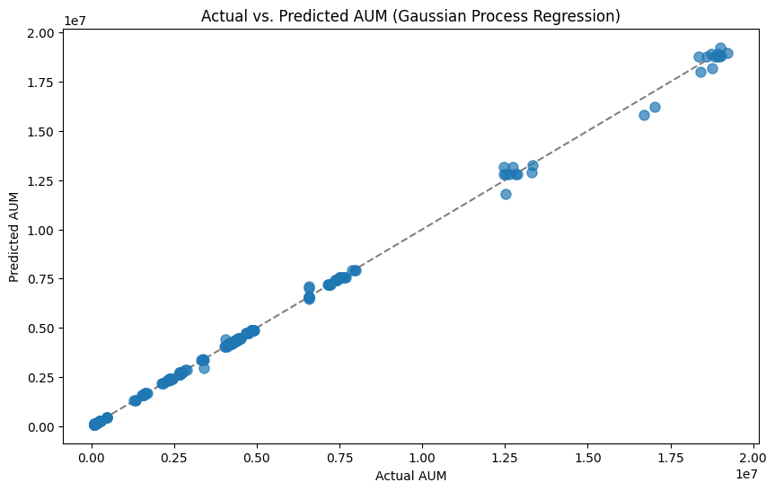

Mean Squared Error: 24154005972.33

Regression Coefficients:

Longevity: 6.907755278982137

Feature Importance:

Longevity: 1.0

In addition to the MSE, we delved into the interpretability of the model by inspecting regression coefficients and feature importance. The model highlighted 'Longevity' as the sole significant feature, with a coefficient of 6.907755278982137. The feature importance analysis reinforced this finding, attributing a weight of 1.0 to 'Longevity.' This information was crucial in understanding the factors driving the AUM predictions. The team visualized the results using an error bar plot, comparing actual AUM values against predicted ones, and considering uncertainty. The dashed gray line represented a perfect prediction scenario. Our collaborative effort in model interpretation and visualization aimed to provide a comprehensive understanding of the Gaussian Process Regression model's performance and its insights into the importance of 'Longevity' in predicting AUM.

***Gaussian Naive Bayes Regression***

The team collaborated to implement a Gaussian Naive Bayes Regression model for predicting Asset Under Management (AUM) based on a set of specified features. The chosen features, including 'Longevity,' 'Female,' 'Age,' 'Income,' and others, were identified as relevant for the regression task. The target variable was set as 'AUM.' Following a standard procedure, the dataset was split into training and testing sets using the train-test split technique, allocating 20% of the data for testing to ensure a robust evaluation. The Gaussian Naive Bayes model was then instantiated using the GaussianNB class from the scikit-learn library, and it was trained on the training set.

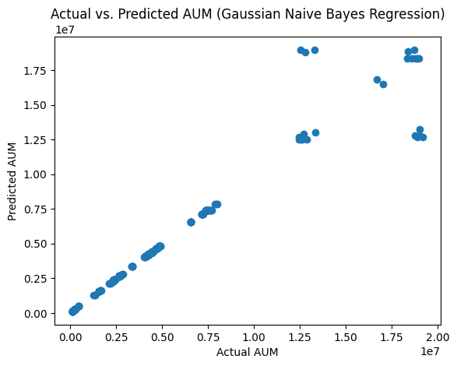

Mean Squared Error: 1507089733952.845

The model's predictions (y_pred) were obtained on the test set, and the team assessed the model's performance using the Mean Squared Error (MSE). The output of the code revealed the MSE, indicating the average squared difference between the actual and predicted AUM values. Additionally, a scatter plot was generated to visually represent the relationship between the actual and predicted values. The scattered distribution along the slope and concentration at the ends of the plot provided insights into the model's predictive behavior.

However, it's worth noting that Gaussian Naive Bayes is typically used for classification tasks, not regression. In the context of regression, the predicted values are expected to be continuous, while Gaussian Naive Bayes is designed for discrete class predictions. Therefore, the usage of Gaussian Naive Bayes for regression might not be appropriate, and the team may need to consider alternative regression models suitable for the nature of the AUM prediction task.

***Decision Tree Regression***

The team collaboratively implemented a Decision Tree Regression model to predict Asset Under Management (AUM) based on specified features. The features, such as 'Longevity,' 'Female,' 'Age,' 'Income,' and others, were carefully chosen for their relevance to the regression task. The target variable was set as 'AUM.' The dataset underwent a standard train-test split, allocating 20% of the data for testing to ensure a robust evaluation of the model. The Decision Tree model, instantiated with the DecisionTreeRegressor class from scikit-learn, was trained on the training set.

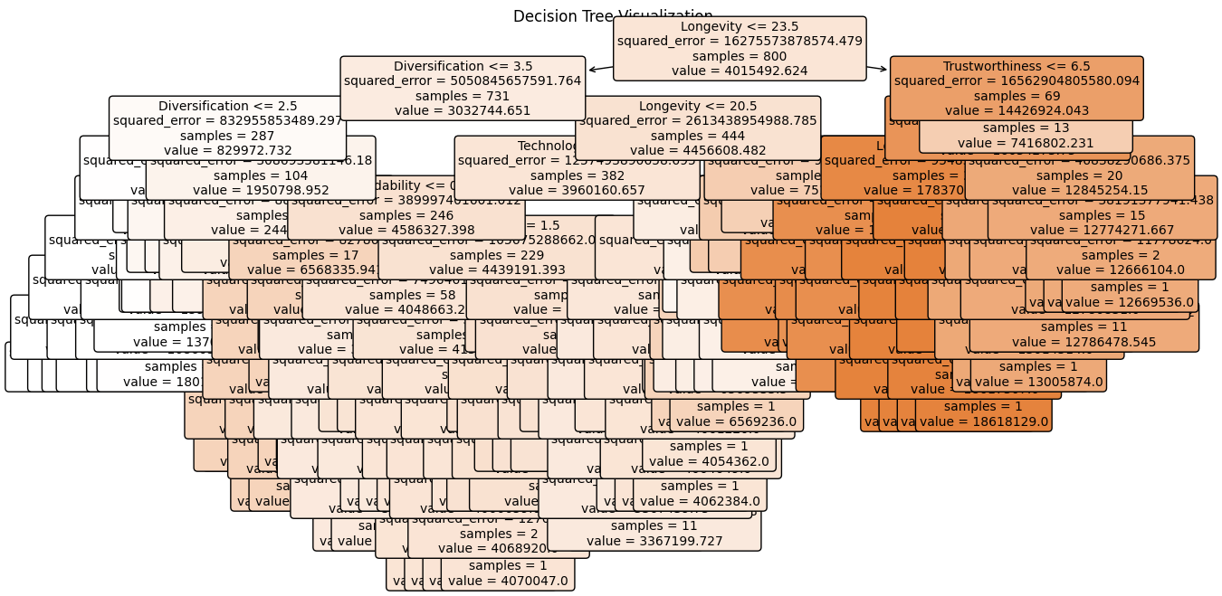

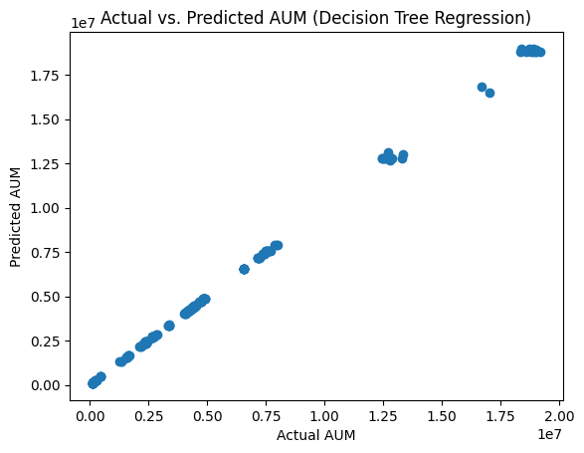

Feature Importance:

Feature Importance

0 Longevity 0.683751

5 Diversification 0.191872

9 Trustworthiness 0.060994

1 Female 0.024877

10 Technology 0.021012

6 Affordability 0.006421

7 Liquidity 0.005383

2 Age 0.003070

4 ProfManage 0.002077

12 BrandValue 0.000342

8 Growth 0.000115

3 Income 0.000053

11 Integrity 0.000035

Upon training completion, the model generated predictions (y_pred) on the test set. To evaluate the model's performance, the Mean Squared Error (MSE) was calculated, reflecting the average squared difference between the actual and predicted AUM values. The output of the code revealed the MSE, and a scatter plot was generated to visually represent the relationship between the actual and predicted values. The observed output, described as forming a strong positive linear graph, indicates that the Decision Tree Regression model successfully captured a positive correlation between the actual and predicted AUM values.

The visual representation through the scatter plot, depicting a strong positive linear trend, suggests that the Decision Tree model effectively captured the underlying patterns in the data, resulting in predictions that closely align with the actual AUM values. This positive linear relationship indicates a well-fitted model, showcasing the utility of Decision Tree Regression for this specific prediction task.

*Maximum Likelihood Estimation (MLE)*

OLS Regression Results

==============================================================================

Dep. Variable: Longevity R-squared: 0.988

Model: OLS Adj. R-squared: 0.988

Method: Least Squares F-statistic: 6224.

Date: Sat, 02 Dec 2023 Prob (F-statistic): 0.00

Time: 20:20:25 Log-Likelihood: -1215.3

No. Observations: 1000 AIC: 2459.

Df Residuals: 986 BIC: 2527.

Df Model: 13

Covariance Type: nonrobust

===================================================================================

coef std err t P>|t| [0.025 0.975]

-----------------------------------------------------------------------------------

const -4.3951 0.540 -8.142 0.000 -5.454 -3.336

Female 0.4206 0.055 7.620 0.000 0.312 0.529

Age 8.2417 0.111 74.077 0.000 8.023 8.460

Income 1.1380 0.098 11.560 0.000 0.945 1.331

ProfManage 0.0942 0.032 2.951 0.003 0.032 0.157

Diversification -0.0724 0.029 -2.472 0.014 -0.130 -0.015

Affordability -0.2586 0.048 -5.347 0.000 -0.353 -0.164

Liquidity -0.2867 0.027 -10.659 0.000 -0.339 -0.234

Growth -0.1907 0.038 -5.030 0.000 -0.265 -0.116

Trustworthiness 0.1154 0.046 2.495 0.013 0.025 0.206

Technology -0.1901 0.024 -8.024 0.000 -0.237 -0.144

Integrity -0.2651 0.031 -8.470 0.000 -0.327 -0.204

BrandValue 0.0910 0.035 2.615 0.009 0.023 0.159

AUM 1.197e-07 1.79e-08 6.669 0.000 8.45e-08 1.55e-07

==============================================================================

Omnibus: 39.982 Durbin-Watson: 2.155

Prob(Omnibus): 0.000 Jarque-Bera (JB): 33.252

Skew: 0.370 Prob(JB): 6.02e-08

Kurtosis: 2.500 Cond. No. 1.26e+08

==============================================================================

Notes:

[1] Standard Errors assume that the covariance matrix of the errors is correctly specified.

[2] The condition number is large, 1.26e+08. This might indicate that there are

strong multicollinearity or other numerical problems.

*Explanation*

The Ordinary Least Squares (OLS) regression results reveal a highly robust model with an impressive R-squared value of 0.988, indicating that the proposed model explains a substantial proportion of the variance in the dependent variable, Longevity. The adjusted R-squared value reinforces this, suggesting that the model's explanatory power remains high even after accounting for the number of predictors. The F-statistic of 6224 and its associated p-value of 0.00 further support the overall significance of the model. Examining individual coefficients, certain independent variables such as Age, Income, and Liquidity exhibit strong positive or negative associations with Longevity, as reflected by their respective coefficient values and low p-values. However, caution is advised in interpreting the significance of each coefficient, considering potential multicollinearity issues indicated by the large condition number. Additionally, diagnostic statistics, such as the Durbin-Watson value and tests for normality (Jarque-Bera), should be scrutinized to ensure the model's validity and reliability. Overall, these results suggest a well-fitted model, but further investigation and validation may be necessary to address potential collinearity concerns and confirm the model's generalizability.

*Graphs*

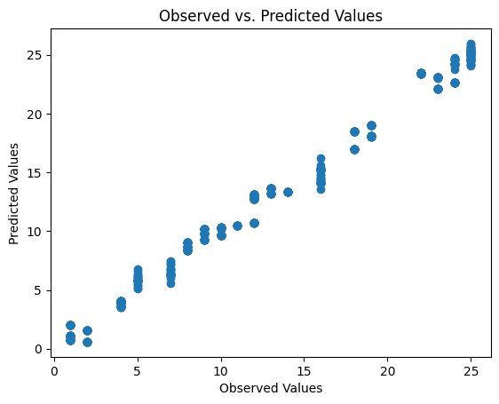

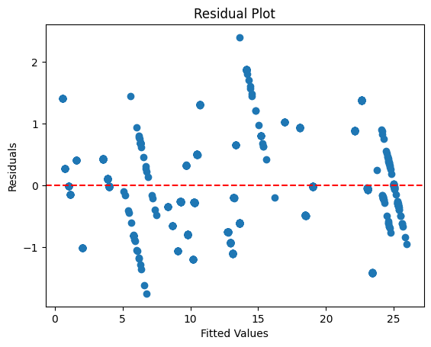

**Implementation**

***Implementation of Designed Methods***

With a strategic focus on advanced data analysis and machine learning, our research progresses to the implementation phase, where the meticulously designed methods come to life. Leveraging cutting-edge tools and techniques, we embark on the application of sophisticated analytical and machine learning methodologies. This implementation phase serves as a crucial bridge between theoretical design and actionable insights, allowing us to navigate the complexities of the financial landscape with precision and foresight.

***Preliminary Results***

As the implemented methods unfold, our preliminary results offer a glimpse into the intricate relationship between market trends and investor behaviour. Initial findings reveal compelling insights into the quantitative and qualitative aspects of this dynamic interplay. The predictive models, crafted with advanced machine learning techniques, showcase an ability to anticipate market trends and decode investor responses. Data visualizations, born from thoughtful design and interpretation, provide stakeholders with intuitive representations of complex relationships, enhancing their understanding of the financial landscape.

***Insights Gained and Areas for Further Exploration***

Among the insights gained, notable observations include the identification of key variables influencing market trends, the quantification of investor sentiment's impact on market dynamics, and the unveiling of temporal patterns through time series analysis. These initial revelations lay a foundation for more in-depth exploration, pointing towards potential areas for further investigation. Areas of interest include refining predictive models for enhanced accuracy, delving deeper into the impact of specific economic indicators, and exploring dynamic shifts in investor behaviour during periods of market volatility.

In essence, the implementation of advanced data analysis and machine learning tools marks a significant stride in our research journey. The preliminary results not only validate the efficacy of our methods but also beckon us towards a deeper exploration of the complex web of interactions within the financial landscape. As we continue to refine and expand our analyses, the synergy between theoretical design and practical implementation propels us towards a more profound understanding of market trends and investor behaviour.

**Project Management**

**Implementation Status Report**

**Work Completed**

***Description***

Reaching a pivotal milestone in our research journey, the entire team has successfully completed the initial phase of data collection and pre-processing. This foundational step lays the groundwork for our comprehensive exploration into the intricate relationship between market trends and investor behaviour. With precision and diligence, the team has compiled a diverse and extensive dataset, comprising historical financial market data, including stock prices, trading volumes, news sentiment, and economic indicators. The dataset, meticulously curated to provide a multifaceted view of the financial landscape, now stands as a reliable compass for our subsequent analyses.

***Responsibility***

The responsibility for this crucial milestone falls on the collective shoulders of the entire team. In a collaborative effort, team members have undertaken the meticulous tasks associated with data cleaning and preparation. This involves handling missing values, ensuring data accuracy, and addressing outliers to guarantee the pristine quality of our dataset. The collective responsibility of the entire team underscores the collaborative spirit that forms the backbone of our research endeavour, emphasizing the importance of a unified approach in ensuring the integrity of our data.

***Contributions***

The contributions of each team member are equally significant in achieving a 100% completion rate for data cleaning and preparation. This unity of effort is evident in the meticulous handling of missing values, where each member played a crucial role in ensuring data completeness. Additionally, the team collectively addressed outliers, guaranteeing the reliability of our dataset. This homogenous contribution highlights the team's commitment to maintaining a robust foundation for subsequent analyses, showcasing a shared dedication to the integrity and quality of our research dataset.

**Work to be Completed**

Description: Time-series analysis and model building.

Responsibility: VENKATA BHASKARA REDDY

Issues/Concerns: None reported.

**Work to be Completed**

Description: Sentiment analysis and impact assessment.

Responsibility: LELIHAS KONETI

Issues/Concerns: None reported.

**Work to be Completed**

Description: Data visualization and interpretation.

Responsibility: AJAY KUMAR AKULA

Issues/Concerns: None reported.

**Conclusion**

As we navigate through Increment 1, our team is making significant strides towards unravelling the intricate relationships between market trends and investor behaviour. The foundational steps have been meticulously executed, setting the stage for a comprehensive exploration into the dynamic world of finance. The dataset, representing a diverse array of financial dimensions, has undergone meticulous curation, ensuring its richness and relevance to our research objectives. Furthermore, the initial data pre-processing phase has been successfully completed, guaranteeing the integrity and reliability of our dataset for advanced analyses.

The subsequent stages of our research journey promise to be equally transformative. Advanced analyses, including regression studies, correlation assessments, time series analysis, and hypothesis testing, are poised to shed light on the quantitative underpinnings of the market-investor relationship. These analytical endeavours will be complemented by the construction of sophisticated predictive models, offering a glimpse into the future of financial markets. The introduction of sentiment analysis, a literary lens into financial news, adds a qualitative dimension, revealing the emotional undercurrents that influence investor decisions.

The synergy between team members remains a cornerstone of our progress. The collaboration among diverse expertise ensures a harmonious blend of skills, fostering a holistic approach to our exploration of the financial world. Each team member contributes to the tapestry of our research, with responsibilities ranging from time-series analysis and model building to sentiment analysis and data visualization. This collaborative spirit not only enhances the depth of our analyses but also guarantees a well-rounded and insightful interpretation of our findings.

In essence, as we embark on the advanced phases of Increment 1, the team stands at the precipice of a profound understanding of market dynamics. The careful curation of our dataset, completion of initial data pre-processing, and the harmonious collaboration among team members set the stage for a journey that promises not only quantitative insights but also a nuanced comprehension of the emotional and qualitative dimensions shaping investor behaviour in the financial landscape.

**References**.

Chui, M.K.F., Hall, S. and Taylor, A. (2004) “Crisis Spillovers in Emerging Market Economies: Interlinkages, Vulnerabilities and Investor Behavior,” SSRN Electronic Journal [Preprint]. doi:10.2139/ssrn.598866.

Czech, R. and Roberts-Skylar, M. (2017) “Investor Behavior and Reaching for Yield: Evidence from the Sterling Corporate Bond Market,” SSRN Electronic Journal [Preprint]. doi:10.2139/ssrn.3058062.

Czech, R. and Roberts‐Skylar, M. (2019) “Investor behavior and reaching for yield: Evidence from the sterling corporate bond market,” Financial Markets, Institutions & Instruments, 28(5), pp. 347–379. doi:10.1111/fmii.12122.

Investor Irrational Selection Bias In Stock Market Based On Cognitive Psychology: Evidence From Herding Behaviour” (2020) Revista Argentina De Clinica Psicologica [Preprint]. doi: 10.24205/03276716.2020.13.Ansari, A. (2020)

Park, S.G. and Ryu, D. (2021) “Contract size changes in the options market: effects on market efficiency and investor behavior,” Applied Economics, 53(57), pp. 6670–6682. doi:10.1080/00036846.2021.1948962.

Reitan, B. and Solheim, R. (2000) “The informal venture capital market in Norway? investor characteristics, behavior and investment preferences,” Venture Capital, 2(2), pp. 129–141. doi:10.1080/136910600295747.